

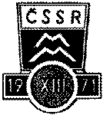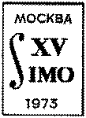

IMO 1969 – 1978

Questions and Solutions

N. Russell S.

Contents

1969 Q …………………………………………………………………………………………… 1

1969 S ……………………………………………………………………………………………. 2

1970 Q …………………………………………………………………………………………… 5

1970 S ………………………………………………………………………………………….… 7

1971 Q ……………………………………………………………………………………….… 11

1971 S …………………………………………………………………………….………….… 13

1972 Q …………………………………………………………………………………….…… 16

1972 S ………………………………………………………………………………………….… 1

1973 Q …………………………………………………………………………………………… 1

1973 S ………………………………………………………………………………………….… 1

1974 Q …………………………………………………………………………………………… 1

1974 S ………………………………………………………………………………………….… 1

1975 Q …………………………………………………………………………………………… 1

1975 S ………………………………………………………………………………………….… 1

1976 Q …………………………………………………………………………………………… 1

1976 S ………………………………………………………………………………………….… 1

1977 Q …………………………………………………………………………………………… 1

1977 S ………………………………………………………………………………………….… 1

1978 Q …………………………………………………………………………………………… 1

1978 S ………………………………………………………………………………………….… 1

Sources ………………………………………………………………………………………….. 1

Made in June 2016